# Feature / Use Case Narrative: Quiet Room (QR) Alert distribution

Linda is an ICU nurse responsible for 4 patients. While she is updating documentation at the nursing station one of her patients goes into an alarm state (UC1). This does not generate an audible tone in the patient room (UC2) though Linda could reset or otherwise handle the alert at the bedside (UC3). It does generate an alarm tone at the central station (DAS) (UC4) as well as a notification on her mobile device (DIS) (UC6). Since she is already at the central station, she can check the situation, reset the alert and otherwise adjust the alert parameters using the central station UI (UC5), and rush to the patient’s room in order to resolve the critical situation.

While she is still taking care of the first patient, another patient goes into an alarm state (UC1) once again generating alarm tones at the central station (UC4) and on her phone (UC6) but not in the patient room. Linda decides to acknowledge the alert on her phone (UC7) and take care of the other patient after she is done with the first patient.

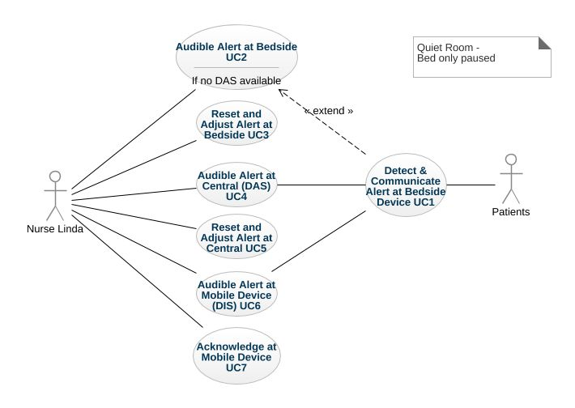

## Rule: Combination of primary and secondary remote alert systems

There is a combination of primary and secondary remote alert systems (e.g. mobile alerting device system, central monitoring station, etc.) compliant with the IEC 60601-1-8 alarm standard for Distributed Alarm Systems (DAS) as well as for Distributed Information System about Alarm Conditions (DIS).

## QR Use Case 1: Detect & Communicate Alert at Bedside Device

### Scenario 1.1: Medical device detects an alert situation and all remote alert systems are accessible (Happy Path)

**Given** alert event was detected by a medical device attached to the patient

**When** all remote alert systems are accessible

**Then** the alert shall be shown on all accessible remote alerting devices

**And** the audio alarm shall be enabled on all accessible remote alerting devices

**And** the audio alarm shall be **disabled** on the medical device

### Scenario 1.2: Medical device detects an alert situation and DAS is accessible but DIS is inaccessible

**Given** alert event was detected by a medical device attached to the patient

**When** DAS is accessible

**But** DIS is inaccessible

**Then** the alert shall be shown on all accessible remote alerting devices

**And** the audio alarm shall be enabled on all accessible remote alerting devices

**And** the audio alarm shall be **disabled** on the medical device

### Scenario 1.3: Medical device detects an alert situation and DIS is accessible but DAS is inaccessible

**Given** alert event was detected by a medical device attached to the patient

**When** DIS is accessible

**But** DAS is inaccessible

**Then** the alert shall be shown on all accessible remote alerting devices

**And** the audio alarm shall be enabled on all accessible remote alerting devices

**And** the audio alarm shall be **paused** on the medical device

### Scenario 1.4: Medical device detects an alert situation and all remote alert systems are inaccessible

**Given** alert event was detected by a medical device attached to the patient

**When** all remote alert systems are inaccessible

**Then** the audio alarm shall be enabled on the medical device

### Scenario 1.5: Medical device detects an alert situation, initially DAS is accessible but fails

### Scenario 1.6: Alert situation has been resolved and at least one remote alert system is accessible

**Given** medical device detected that the alert situation has been resolved

**When** at least one remote alert system is accessible

**Then** the alert shall be shown as inactive/ended at the medical device

**And** the audio alarm shall be **disabled** on the medical device

**And** the alert shall be shown as inactive/ended on all accessible remote alerting devices

**And** the audio alarm shall be disabled on all accessible remote alerting device for this alert event

## QR Use Case 2: Audible Alert at Bedside

### Scenario 2.1: Medical device detects an alert situation and no remote alert systems are accessible (same as 1.4)

## QR Use Case 3: Reset and Adjust Alert at Bedside

### Scenario 3.1: Caregiver acknowledges the alert at the Bedside device – DAS and DIS accessible

### Scenario 3.2: Caregiver acknowledges the alert at the Bedside device – DAS accessible, DIS not accessible

### Scenario 3.3: Caregiver acknowledges the alert at the Bedside device – DIS accessible, DAS not accessible

## QR Use Case 4: Audible Alert at Central Station (DAS)

### Scenario 4.1: Medical device detects and alert condition and DAS (CS) announces the alert

## QR Use Case 5: Reset and Adjust Alert at DAS

### Scenario 5.1: Caregiver acknowledges the alert at the DAS

**Given** alert event was detected by a medical device attached to the patient

**And** remote alerting device is part of the DAS

**When** caregiver acknowledges the alert at a remote alerting device

**And** DAS is accessible

**Then** the alert shall be shown as acknowledged at the medical device

**And** the audio alarm shall be **disabled** on the medical device

**And** the alert shall be shown as acknowledged on all accessible remote alerting devices

**And** the audio alarm shall be disabled on all accessible remote alerting devices for this alert event

## QR Use Case 6: Audible Alert at Nurse Device

### Scenario 6.1: Medical device detects an alert condition and DIS announces the alert at Caregiver device

## QR Use Case 7: Acknowledge Alert at Nurse Device

### Scenario 7.1: Caregiver confirms the alert at the DIS and DAS is accessible

**Given** alert event was detected by a medical device attached to the patient

**And** remote alerting device is part of the DIS

**When** caregiver confirms the alert at a remote alerting device

**And** DIS is accessible

**And** DAS is accessible

**Then** the alert shall only be shown as confirmed on all accessible DIS remote alerting devices

### Scenario 7.2: Caregiver confirms the alert at the DIS and DAS is inaccessible

**Given** alert event was detected by a medical device attached to the patient

**And** remote alerting device is part of the DIS

**When** caregiver confirms the alert at a remote alerting device

**And** DIS is accessible

**But** DAS is inaccessible

**Then** the alert shall only be shown as confirmed on all accessible DIS remote alerting devices

**And** the audio alarm shall be **paused** on the medical device

# Feature / Use Case Narrative: Silent Room (SR) Alert distribution

Linda is an ICU nurse responsible for 4 patients. While she is updating documentation at the nursing station one of her patients goes into an alarm state (UC1). This does not generate an audible tone in the patient room (UC2) though Linda could reset or otherwise handle the alert at the bedside (UC3). It does generate an alarm tone at the central station (UC4) as well as a notification on her mobile device (UC6). Since she is already at the central station, she can check the situation, reset the alert and otherwise adjust the alert parameters using the central station UI (UC5), and rush to the patient’s room in order to resolve the critical situation.

While she is still taking care of the first patient, another patient goes into an alarm state (UC1) once again generating alarm tones at the central station (UC4) and on her phone (UC6) but not in the patient room. Linda decides to reset the alert on her phone (UC7), adjust the alarm limits (UC7) and take care of the other patient after she is done with the first patient.

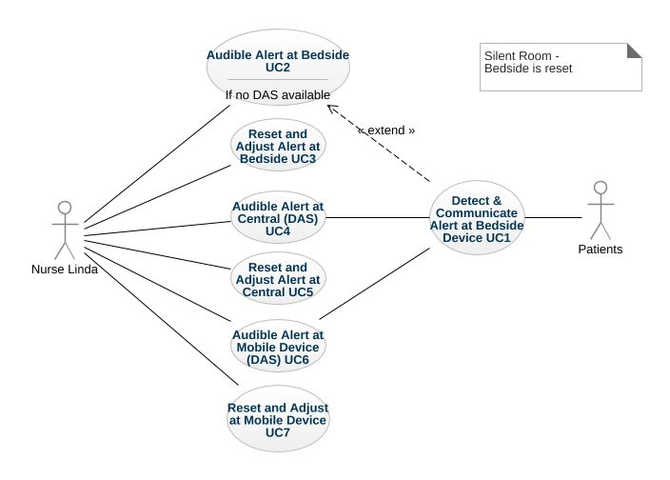

## Rule: Multiple primary remote alert systems

There are multiple primary remote alert systems (e.g. mobile alerting device system, central monitoring station, etc.) compliant with the IEC 60601-1-8 alarm standard for Distributed Alarm Systems (DAS).

## SR Use Case 1: Detect and Communicate Alert at Bedside Device

### Scenario 1.1: Medical device detects an alert situation and at least one remote alert system is accessible

**Given** alert event was detected by a medical device attached to the patient

**When** at least one remote alert system is accessible

**Then** the alert shall be shown on all accessible remote alerting devices

**And** the audio alarm shall be enabled on all accessible remote alerting devices

**And** the audio alarm shall be disabled on the medical device

### Scenario 1.2: Medical device detects an alert situation and all remote alert systems are inaccessible

**Given** alert event was detected by a medical device attached to the patient

**When** all remote alert systems are inaccessible

**Then** the audio alarm shall be enabled on the medical device

### Scenario 1.3: Alert situation has been resolved and at least one remote alert system is accessible

**Given** medical device detected that the alert situation has been resolved

**When** at least one remote alert system is accessible

**Then** the alert shall be shown as inactive/ended at the medical device

**And** the audio alarm shall be disabled on the medical device

**And** the alert shall be shown as inactive/ended on all accessible remote alerting devices

**And** the audio alarm shall be disabled on all accessible remote alerting device for this alert event

### Scenario 1.4: Medical device detects an alert situation, initially DAS is accessible but fails

## SR Use Case 2: Audible Alert at Bedside Device

## Scenario 2.1: Medical device detects and alert condition and DAS announces the alert

## SR Use Case 3

### Scenario 3.1: Caregiver acknowledges the alert at the Bedside device – all remote alert systems are accessible

### Scenario 3.2: Caregiver acknowledges the alert at the Bedside device – one remote alert system is accessible

### Scenario 3.3: Caregiver acknowledges the alert at the Bedside device – no remote alert systems are accessible

## SR Use Case 4: Audible Alert at Central Station (DAS)

### Scenario 4.1: Medical device detects and alert condition and DAS announces the alert

## SR Use Case 5

### Scenario 5.1: Caregiver acknowledges the alert at one of the remote alert systems

**Given** alert event was detected by a medical device attached to the patient

**When** caregiver acknowledges the alert at a remote alerting device

**And** remote alert system connected to this remote alerting device is accessible

**Then** the alert shall be shown as acknowledged at the medical device

**And** the audio alarm shall be disabled on the medical device

**And** the alert shall be shown as acknowledged on all accessible remote alerting devices

**And** the audio alarm shall be disabled on all accessible remote alerting devices for this alert event

## SR Use Case 6: Audible Alert at DAS Nurse Device

### Scenario 6.1: Medical device detects and alert condition and DIS announces the alert at Caregiver device

## SR Use Case 7: Acknowledge Alert at DAS Nurse Device

### Scenario 7.1: Caregiver confirms the alert at their DAS Mobile Device

**Given** alert event was detected by a medical device attached to the patient

**And** remote alerting device is part of the DAS

**When** caregiver confirms the alert at a remote alerting device

**And** DAS is accessible

**Then** the alert shall be shown as acknowledged at the medical device

**And** the audio alarm shall be disabled on the medical device

**And** the alert shall be shown as acknowledged on all accessible remote alerting devices

### Scenario 7.2: Caregiver confirms the alert at their DAS mobile device but the respective DAS is not accessible

**Given** alert event was detected by a medical device attached to the patient

**And** remote alerting device is part of the DIS

**When** caregiver confirms the alert at a remote alerting device

**But** DAS is inaccessible

**Then** ???

# Feature / Use Case Narrative: Silent ICU (SI) Alert distribution

Linda is an ICU nurse responsible for 4 patients. While she is updating documentation at the nursing station one of her patients goes into an alarm state (UC1). This does not generate an audible tone in the patient room (UC2) though Linda could reset or otherwise handle the alert at the bedside (UC3). In addition, it does not generate an alarm tone at the central station (UC4) however it does generate a notification on her mobile device (UC6). Since she is already at the central station, she can check the situation, reset the alert and otherwise adjust the alert parameters using the central station UI (UC5), and rush to the patient’s room in order to resolve the critical situation.

While she is still taking care of the first patient, another patient goes into an alarm state (UC1) once again generating alarm tones and on her phone (UC6) but not at the central station (UC4) or in the patient room. Linda decides to reset the alert on her phone (UC7), adjust the alarm limits (UC7) and take care of the other patient after she is done with the first patient.

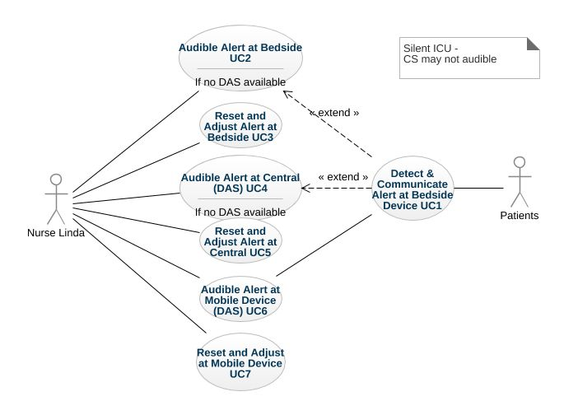

## Rule: Multiple primary remote alert systems

There are multiple primary remote alert systems (e.g. mobile alerting device system, central monitoring station, etc.) compliant with the IEC 60601-1-8 alarm standard for Distributed Alarm Systems (DAS). The central station DAS does not create audible alerts as long as the other DAS is accessible. It will always alert the at the nurse mobile device.

## SR Use Case 1: Detect and Communicate Alert at Bedside Device

### Scenario 1.1: Medical device detects an alert situation and at least one remote alert system is accessible

**Given** alert event was detected by a medical device attached to the patient

**When** at least one remote alert system is accessible

**Then** the alert shall be shown on all accessible remote alerting devices

**And** the audio alarm shall be enabled only on the nurse alerting device

**And** the audio alarm shall be disabled on the medical device

### Scenario 1.2: Medical device detects an alert situation and all remote alert systems are inaccessible

**Given** alert event was detected by a medical device attached to the patient

**When** all remote alert systems are inaccessible

**Then** the audio alarm shall be enabled on the medical device

### Scenario 1.3: Alert situation has been resolved and at least one remote alert system is accessible

**Given** medical device detected that the alert situation has been resolved

**When** at least one remote alert system is accessible

**Then** the alert shall be shown as inactive/ended at the medical device

**And** the audio alarm shall be disabled on the medical device

**And** the alert shall be shown as inactive/ended on all accessible remote alerting devices

**And** the audio alarm shall be disabled on all accessible remote alerting device for this alert event

### Scenario 1.4: Medical device detects an alert situation, initially DAS is accessible but fails

## SR Use Case 2: Audible Alert at Bedside Device

## Scenario 2.1: Medical device detects and alert condition and DAS announces the alert

## SR Use Case 3

### Scenario 3.1: Caregiver acknowledges the alert at the Bedside device – all remote alert systems are accessible

### Scenario 3.2: Caregiver acknowledges the alert at the Bedside device – one remote alert system is accessible

### Scenario 3.3: Caregiver acknowledges the alert at the Bedside device – no remote alert systems are accessible

## SR Use Case 4: Audible Alert at Central Station (DAS)

### Scenario 4.1: Medical device detects and alert condition and DAS announces the alert

## SR Use Case 5

### Scenario 5.1: Caregiver acknowledges the alert at one of the remote alert systems

**Given** alert event was detected by a medical device attached to the patient

**When** caregiver acknowledges the alert at a remote alerting device

**And** remote alert system connected to this remote alerting device is accessible

**Then** the alert shall be shown as acknowledged at the medical device

**And** the audio alarm shall be disabled on the medical device

**And** the alert shall be shown as acknowledged on all accessible remote alerting devices

**And** the audio alarm shall be disabled on all accessible remote alerting devices for this alert event

## SR Use Case 6: Audible Alert at DAS Nurse Device

### Scenario 6.1: Medical device detects and alert condition and DIS announces the alert at Caregiver device

## SR Use Case 7: Acknowledge Alert at DAS Nurse Device

### Scenario 7.1: Caregiver confirms the alert at their DAS Mobile Device

**Given** alert event was detected by a medical device attached to the patient

**And** remote alerting device is part of the DAS

**When** caregiver confirms the alert at a remote alerting device

**And** DAS is accessible

**Then** the alert shall be shown as acknowledged at the medical device

**And** the audio alarm shall be disabled on the medical device

**And** the alert shall be shown as acknowledged on all accessible remote alerting devices

### Scenario 7.2: Caregiver confirms the alert at their DAS mobile device but the respective DAS is not accessible

**Given** alert event was detected by a medical device attached to the patient

**And** remote alerting device is part of the DIS

**When** caregiver confirms the alert at a remote alerting device

**But** DAS is inaccessible

**Then** ???

## Rule / Pre-Condition: One primary remote alert system

There is one primary remote alert system (e.g. mobile alerting device system, central monitoring station, etc.) compliant with the IEC 60601-1-8 alarm standard for Distributed Alarm Systems (DAS).

### Scenario: Caregiver acknowledges the alert at the remote alerting device

**Given** alert event was detected by a medical device attached to the patient

**When** caregiver acknowledges the alert at the remote alerting device

**And** remote alert system is accessible

**Then** the alert shall be shown as acknowledged at the medical device

**And** the audio alarm shall be disabled on the medical device

**And** the alert shall be shown as acknowledged on the caregiver’s remote alerting device

**And** the audio alarm shall be disabled on the caregiver’s remote alerting device for this alert event

### Scenario: Alert situation has been resolved and remote alert system is accessible

**Given** medical device detected that the alert situation has been resolved by the caregiver

**When** remote alert system is accessible

**Then** the alert shall be shown as inactive/ended at the medical device

**And** the audio alarm shall be disabled on the medical device

**And** the alert shall be shown as inactive/ended on the caregiver’s remote alerting device

**And** the audio alarm shall be disabled on the caregiver’s remote alerting device for this alert event

### Scenario: Medical device detects an alert situation and remote alert system is inaccessible

**Given** alert event was detected by a medical device attached to the patient

**When** remote alert system is inaccessible

**Then** the audio alarm shall be enabled on the medical device

# Feature: Audio alarm behavior dependent on the presence of caregiver in patient room

Claire is an ICU nurse and responsible for patients which have severe infectious disease and therefore, these patients are housed in isolation rooms in order to prevent the spread of diseases in the hospital. According to hospital’s protocol for isolation rooms, she has to wear protective clothing and is not allowed to use her mobile device in the isolation room. Therefore, before she enters the isolation room, Claire suspends the audio alarm delegation for all the bedside device in the isolation room through her mobile device, so that she will directly acoustically be notified by the devices in the isolation room detecting an alarm event.  
At another care unit, the caregivers are automatically located, and when the system detects the presence of a caregiver in the isolation room the system automatically suspends the audio alarm delegation.

### Scenario Outline: Caregiver is not present in the patient room and a remote alerting system according is accessible

**Given** caregiver indicated his/her absence or the absence of a caregiver was automatically detected

**When** there is an alert event on one or more medical devices in the patient room

**And** remote <system> alerting system is accessible

**Then** the alerts on the medical devices shall be shown on the remote alerting devices

**And** the audio alarm shall be enabled on the remote alerting devices

**And** the audio alarm shall be <action> on the medical devices in the patient room

Examples:

| system | action |

| DAS | disabled |

| DIS | paused |

### Scenario Outline: Caregiver is present in the patient room and a remote alerting system is accessible

**Given** caregiver indicated his/her presence or the presence of a caregiver was automatically detected

**When** there is an alert event on one or more medical devices in the patient room

**And** remote <system> alerting system is accessible

**Then** the alerts on the medical devices in the patient room shall be shown on the remote alerting devices

**And** the audio alarm shall be <action> on the remote alerting devices for these alert events

Examples:

| system | action |

| DAS | disabled |

| DIS | enabled |

### Scenario: Caregiver is not present in the patient room and a remote alerting system is inaccessible

**Given** caregiver indicated his/her absence or the absence of a caregiver was automatically detected

**When** there is an alert event on one or more medical devices in the patient room

**And** remote alerting system is inaccessible

**Then** the audio alarm shall be enabled on the medical devices in the patient room

## Rule: Individual audio alarming on all medical devices is configured

Per configuration, the audio alarm delegation is suspended on all medical devices in the patient room when a caregiver is present in the patient room.

### Scenario: Caregiver is present in the patient room

**Given** caregiver indicated his/her presence or the presence of a caregiver was automatically detected

**When** there is an alert event on one or more medical devices in the patient room

**Then** the audio alarm shall be enabled on all medical devices which have an alert event

## Rule: Only audio alarming for alert events with highest priority is configured

Per configuration, the audio alarm is enabled only for the devices which have alert events with the highest priority.

### Scenario: Caregiver is present in the patient room

**Given** caregiver indicated his/her presence or the presence of a caregiver was automatically detected

**When** there is an alert event on one or more medical devices in the patient room

**Then** the audio alarm shall only be enabled on the medical devices which have alert events with the highest priority

**But** the audio alarm shall still be disabled on medical devices which have alert events with a lower priority

## Rule: Dedicated alert notifier device is configured

Per configuration, the audio alarm is disabled on all medical devices except for dedicated alert notifier device which has its audio alarm enabled and all other devices delegate their audio alarm to this device.

### Scenario: Caregiver is present in the patient room and the alert notifier device is accessible

**Given** caregiver indicated his/her presence or the presence of a caregiver was automatically detected

**When** there is an alert event on one or more medical devices in the patient room

**And** the dedicated alert notifier device is accessible

**Then** alert events from all medical devices in the patient rooms shall be shown at the dedicated alert notifier device

**And** the audio alarm shall only be enabled on the dedicated alert notifier device

**And** the audio alarm shall be disabled on all other medical devices

### Scenario: Caregiver is present in the patient room and the alert notifier device is inaccessible

**Given** caregiver indicated his/her presence or the presence of a caregiver was automatically detected

**When** there is an alert event on one or more medical devices in the patient room

**And** the dedicated alert notifier device is inaccessible

**Then** the audio alarm shall be enabled on all medical devices which have an alert event